**CODE:**

**#include <stdio.h>**

**#include <stdbool.h>**

**#include <freertos/FreeRTOS.h>**

**#include <freertos/task.h>**

**#include <esp_err.h>**

**#include "ultrasonic.h"**

**#define ECHO_GPIO 12**

**#define TRIGGER_GPIO 13**

**#define MAX_DISTANCE_CM 500**

**void ultrasonic_test(void *pvParameters)**

**{**

**float distance;**

**ultrasonic_sensor_t sensor = {**

**.trigger_pin = TRIGGER_GPIO,**

**.echo_pin = ECHO_GPIO**

**};**

**ultrasonic_init(&sensor);**

**while (true) {**

**esp_err_t res = ultrasonic_measure(&sensor, MAX_DISTANCE_CM, &distance);**

**if (res == ESP_OK) {**

**printf("Distance=%0.05f m\n", distance);**

**}**

**else {**

**printf("Error %d: ", res);**

**switch (res) {**

**case ESP_ERR_ULTRASONIC_PING:**

**printf("Cannot ping \n");**

**break;**

**case ESP_ERR_ULTRASONIC_PING_TIMEOUT:**

**printf("Ping timeout\n");**

**break;**

**case ESP_ERR_ULTRASONIC_ECHO_TIMEOUT:**

**printf("Echo timeout \n");**

**break;**

**default:**

**printf("%s\n", esp_err_to_name(res));**

**}**

**}**

**vTaskDelay(pdMS_TO_TICKS(500));**

**}**

**}**

**void app_main()**

**{**

**xTaskCreate(ultrasonic_test, "ultrasonic_test", configMINIMAL_STACK_SIZE * 3, NULL, 5, NULL);**

**}**

**CIRCUIT:**

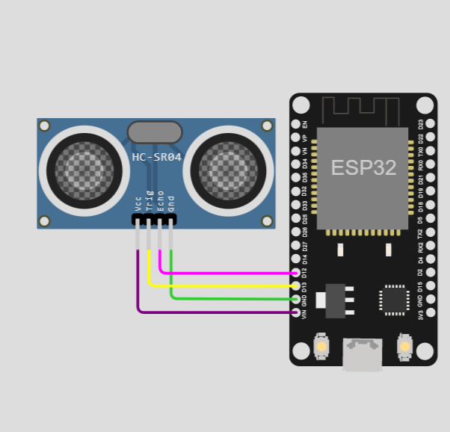

**OUTPUT:**

**Distance=4.0564 m**

**Distance=1.1914 m**